### **3. Without a quality online experience, fashion brands face bankruptcy**

Traditional fashion retailers that did not innovate could still keep afloat in the pre-pandemic era. Now, when the customers' focus rapidly switched to online shopping, years of stagnation and reliance on outdated marketing techniques have come to the surface.

A new situation threatens not only revenue but the complete viability and existence of a company.

At the end of 2020, the fashion world was struck with the news that UKs Arcadia Group, which owns Topshop, Miss Selfridge, and Dorothy Perkins, was hit hard by the pandemic on the brink of bankruptcy.

**Like other traditional High Street brands, Topshop has struggled with digital marketing and sales transformation, and digital innovation. Topshop has been completely overshadowed by online fashion platforms like Asos, Zalando, and even Zara and H&M that have a formidable online experience.**

To survive, brands must invest not only into an online presence, but online presence with a quality experience. The quality online experience was offered by online-first providers like Pret-a-Porter, Farfetch, and Asos, and it includes:

* focus on customer experience
* free returns
* no minimum free shipping
* customer product feedback
* etc.

### **4. Even online-first fashion brands face revenue turmoil**

Online fashion brands like Pret-a-Porter, Farfetch, Asos, and Zalando are clear winners in this Covid and post Covid age, but they also face tough challenges in their 2020 earning report.

### **5. Digital fashion platforms are disrupting the fast fashion economy**

Fast fashion has really lived up to its name. Brands like Zara, H&M, and ASOS reported growth year after year, but for how long? Online shoppers are starting to care more about their purchase experience, leading to a drop in site traffic across many fast fashion brands. According to a Gartner L2 report, Zara had 6%, H&M 10%, and Forever21 had 26% fewer web visits in 2019 than in 2018.

Why is that happening? The new batch of disruptors has raised the bar of digital sophistication, focusing on quality, user experience, and functionality, and threatened the fast fashion specialty retailers.

Key brands in this field include Farfetch, Net-a-Porter, Asos, and Zalando.

‍

### **6. Reviews are the key to fighting high return rates**

Asos, one of the biggest names in the online fashion e-commerce, recently tweeted asking their customers what they want to see in their app. Two of the most liked comment were about the reviews. People trust other people, simple as that. This is a sure way of fighting what is one of the biggest problems in the fashion e-commerce - high rates of returns. When you're shopping online, you need to find the clothes of the right size without the option of trying these clothes on before buying. Thats why he majority of online shoppers over-order to ensure they find the right size. After all, online shoppers are tasked with finding clothes that fit even though they don’t have the opportunity to try these clothes on before buying. Some even take part in a social media challenge [“snap and send back”](https://365retail.co.uk/snap-and-send-back/) whereby consumers buy simply for the purposes of posting an #OOTD (Outfit of the day) picture on Instagram, then return the item(s).

### **7. AR shopping**

It's much more convenient to shop from home, but there is definitely some downsides to online shopping. When you're shopping for clothes online, you can't try on the clothes, feel the fabric or instantly know does something fit or not. The lack of physical connection often can lead to shopper hesitation and lead to fewer sales. But the new technologies like augmented reality and virtual reality can help to overcome this obstacle.

AR has been integrated in multiple shops with success. This technology doesn't offer a full immersive experience as VR, but it can overlay different digital images atop real-world surroundings, making the shopping experience engaging, unique and personal.

How many times have you considered buying something online, but you weren’t sure where to put it or if it would look in a particular spot? With this capability, shoppers can easily visualize how the item will fit into their home, making their decision easier and increases the likelihood of a purchase.

For example, Shopify’s Daniel Beauchamp and his team explore how these technologies will fundamentally change the future of retail in the following video: [Youtube video link](https://www.youtube.com/watch?v=b1vm5ltwytQ)

‍



Please see the top 10 lis of innovative fashion AR concepts in our article [Top Fashion AR App Concepts](https://www.supersuperagency.com/blog/top-fashion-ar-app-concepts)  
‍

### **10. Video is still on the rise**

Video is already pretty popular on eCommerce—but it’s still growing.

There’s no mystery why retailers are gravitating toward more videos—they can [increase conversions, click-through rates, and web traffic](http://awesome.vidyard.com/rs/273-EQL-130/images/Vidyard_Aberdeen_Impact_of_Video_Marketing.pdf). In fact, Forbes found that [65 percent of customers](https://www.forbes.com/sites/forbesagencycouncil/2017/02/03/video-marketing-the-future-of-content-marketing/#78fd5a986b53) are more likely to make a purchase after watching a product video.

Shoppers are attracted to this advertising method because it feels more authentic and can provide valuable information. Dollar Shave Club experienced first-hand how effective video marketing can be when its unexpectedly funny [first video received nearly five million views and generated 12,000 orders](https://jilt.com/upsell/dollar-shave-club-video/) within the first two days of its release.

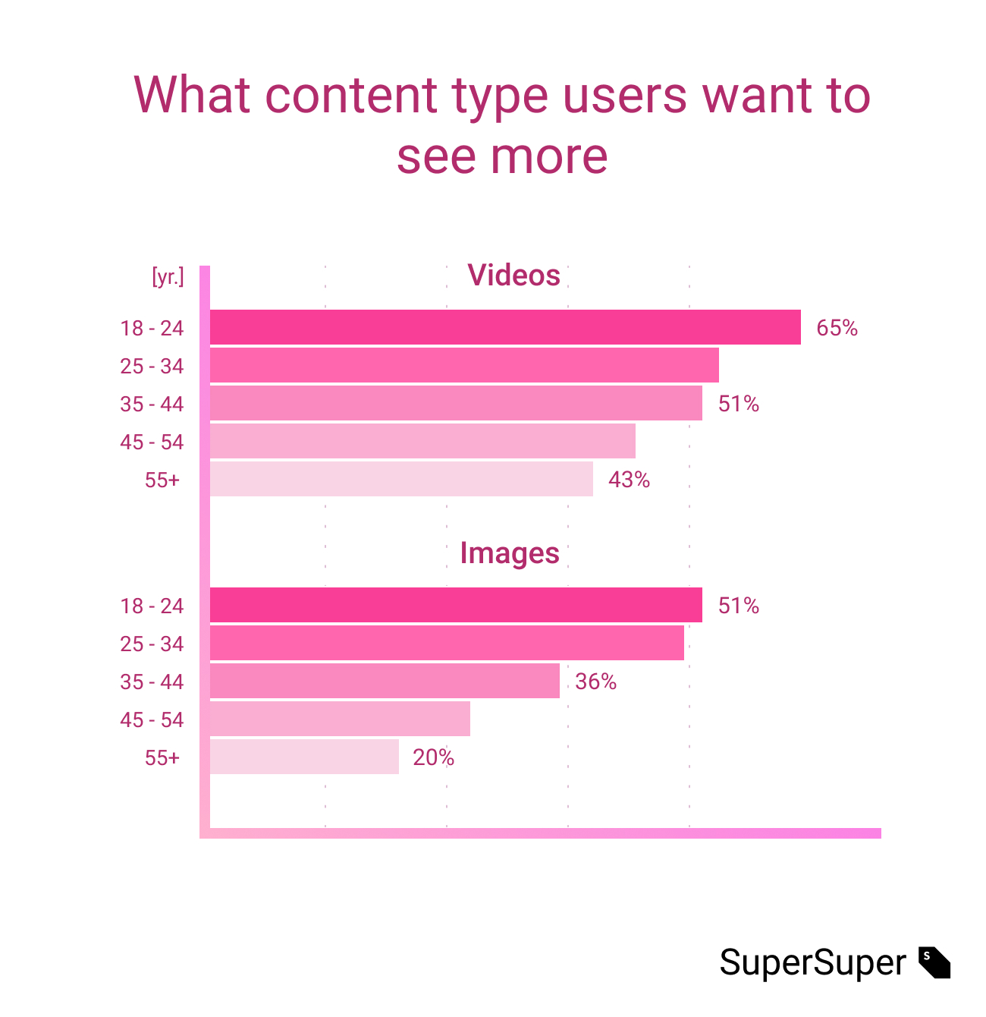

Source: [HubSpot.com](https://blog.hubspot.com/news-trends/content-trends-preferences)

This format is so beneficial because it’s very easy to share and elicits an emotional reaction from viewers. The Aberdeen Group found that companies utilizing video in ad campaigns [boosted revenue 49 percent](http://awesome.vidyard.com/rs/273-EQL-130/images/Vidyard_Aberdeen_Impact_of_Video_Marketing.pdf) more quickly year-after-year than those that do not.

**According to Cisco, video will be**[**82 percent of all internet traffic**](https://www.cisco.com/c/en/us/solutions/collateral/service-provider/visual-networking-index-vni/white-paper-c11-741490.html#_Toc532256789)**by 2022. That’s up four-fold over 2017 and demonstrates just how important video will be to eCommerce (and all businesses) in the coming years.**

Experiment with one or more of the following video formats and add embedded videos to your product pages or link to videos in your Jilt [post-purchase emails](https://jilt.com/product/lifecycle-emails/) to pique customer interest and boost revenue.

Product demos

* Allow consumers to see the product from a 360-degree angle
* Highlight and explain major features
* Answer common customer questions

How-to videos

* Delve deeper into a product’s features and demonstrate how to use them
* Popular video type for social media
* Get customers excited about everything your product can do

User-generated customer reviews

* Build trust in your product
* Add a layer of authenticity to your reviews

Lifestyle

* Build a narrative around your brand and tell stories about your product
* Videography feels more like a movie or short film
* Great for your social media platforms  
  ‍

### **11. Shoppable ads on social media**

Both Google and Instagram introduced shoppable ads in the past couple of months. We will only see more of this trend, making it super easy to shop while you're scrolling on Instagram. The photo-sharing social media platform is quickly becoming the [central hub](https://www.shopify.com/enterprise/ecommerce-fashion-industry) for branded fashion content and powerful user-generated marketing. In the fashion industry, it can be difficult to build trust. By turning to influencers, fashion brands can gain endorsements from trusted product curators who boast massive followings.

Not only that, but retailers could learn a thing or two from Instagram when it comes to shopping on mobile. The app has made the customer journey to purchase super easy with a [native payment integration](https://techcrunch.com/2018/05/03/instagram-payments/) into the app.

In May 2020. Facebook introduced [Facebook shop](https://www.facebook.com/zuck/videos/10111929914173161/) - further shopping integration to Facebook. Instagram also added [on-platform checkout](https://digiday.com/retail/checkout-feature-forces-brands-rethink-instagram-reliance/)where the user can order the product completely through the social platform. This features greatly increased options for small business to stay afloat during Covid19 crisis where brick and mortar shops experienced lower traffic.

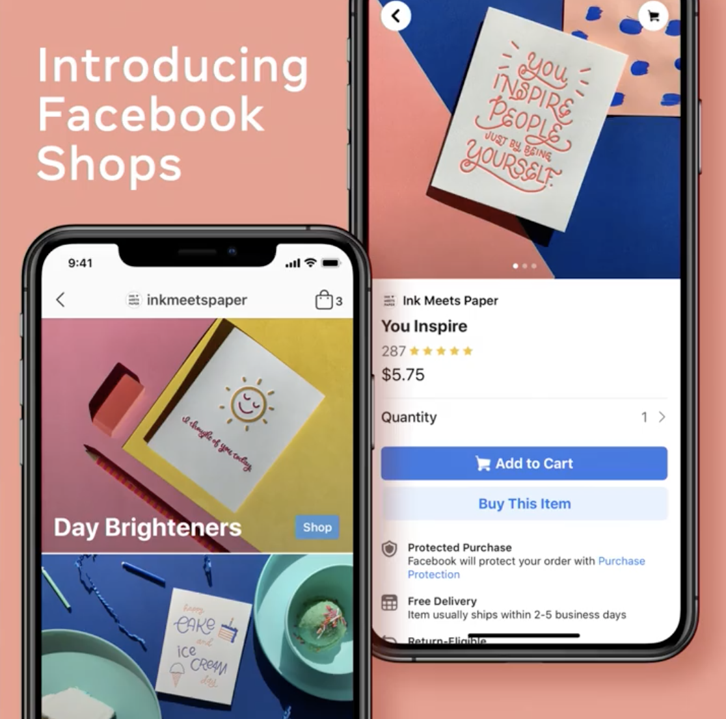

‍

### **12. Brands are reducing wait time with the help of chatbots**

eCommerce customers love to chat. According to one study, [51 percent](https://martech.zone/live-chat-statistics-infographic/) are more likely to make a purchase if they can have a live chat, and 44 percent say having their questions answered in real-time is one of the most important features an eCommerce site can offer.

And that’s cool… except it’s a big ask for a small company, and an impossible ask for someone running an eCommerce business solo.

That’s where [chatbots](https://jilt.com/upsell/ecommerce-chatbots/) come in. Rather than answering every question yourself in real-time, why not have a robot do it—or, at least, serve as an initial screener?

Chatbots certainly have its limitations as they are not smart as humans yet, but, some interactions can successfully be handled by bot (intro talk at least).

And chatbot technology isn’t just available to companies that can afford AI developers or ones that have been building a secret army of robots in a sub-basement. There are plenty of affordable and simple chatbot apps available right now for both [Shopify](https://apps.shopify.com/search?q=chatbot) and [WooCommerce](https://wordpress.org/plugins/search/chatbot/).

With this list of trends, you will understand the current 2021 fashion industry trends. To make the most out of the trend list please download the [a guide on how to leverage trends and innovate](https://www.supersuperagency.com/resources/how-to-leverage-trends-and-foster-a-company-innovation-culture-guide).  
‍

### **15. Personalisation**

Customers seek which product will fit his or her unique needs; for example; a customer searching for a jacket will want to search a “Warm rain-resistant white jacket”.  
Implementing a personalised customer-first approach means avoiding sales pushiness, flashy banners and orientation on the actual customer needs and goals.

Various tools offer solutions for personalisation across offline and online touchpoints. New retail personalisation platforms like [qubit.com](https://www.qubit.com/) offer tools to personalise the experience across channels and touchpoints.

Personalisation can be achieved by implementing new AI product recommendations, CRM tools, and by implementing a customer-centric environment. Every department must accept this new shift or risk being challenged by industry disruptors.

[[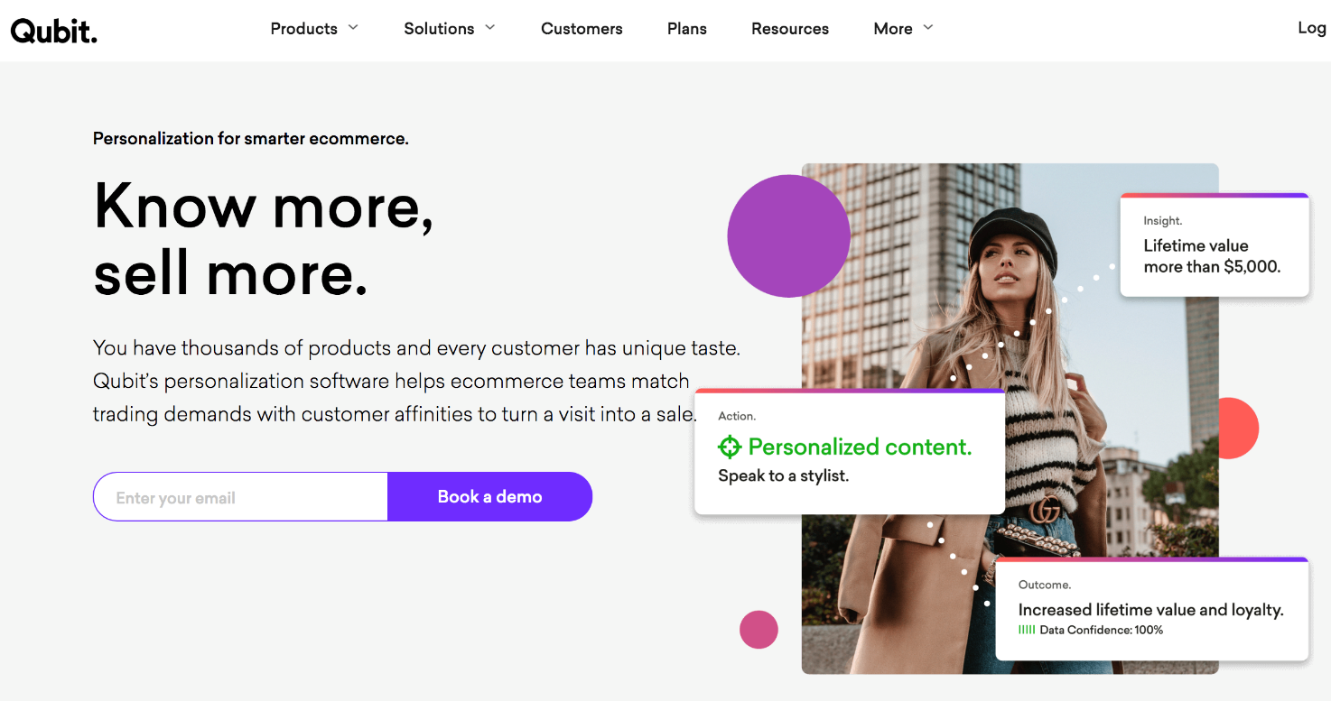](https://www.qubit.com/)](https://www.qubit.com/" \t "_blank)

### **16. Ethical marketing**

Brands are differentiating and gaining customer loyalty based on values and ethical marketing. Sales tricks and sneaky tactics will only bring short term results but completely destroy your reputation and retention. The goal is to offer the customer a solution that balances sales tactics and long term values.

Example: weekday.de "Re-think: animals"

[[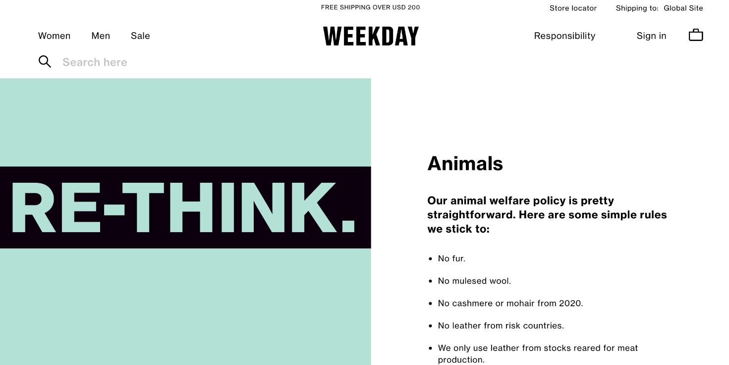](https://www.weekday.com/en/sustainability/animals.html)](https://www.weekday.com/en/sustainability/animals.html" \t "_blank)

Weekday animal welfare policy:

* No fur.
* No mulesed wool.
* No cashmere or mohair from 2020.
* No leather from risk countries.
* etc..

The Weekday customer feels connected to the brand cause and feels the brand "speak their language".